 |  |  | 
TIO | FOR SALE  BY WAY OF AN INFORMAL TENDER |  | Land at Holt Lane, Netherley, Liverpool, L27
Industrial & Business Redevelopment Opportunity Subject to Planning Consent

==` |  |  | 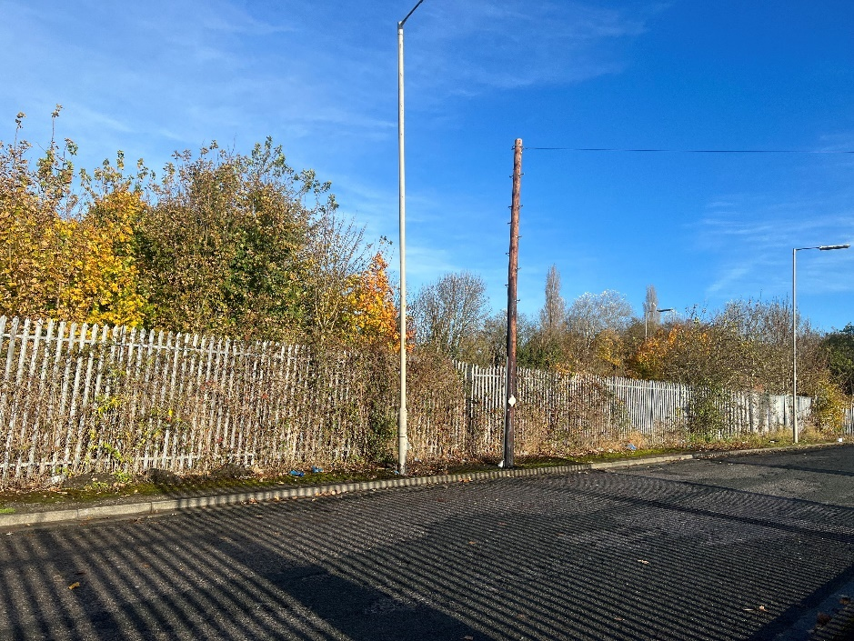

Description/Background:
Approximately 0.98 acres of land which contains overgrowth consisting of trees and vegetation along with additional remedial repairs such as fencing and pavement reinstatement. A Japanese knotweed survey was carried out in March 2025 finding no evidence of Japanese knotweed on site.

Liverpool City Council are welcoming Expressions of Interest to redevelop the site into industrial or business use. The property will be disposed of by way of an informal tender, the interested parties should put forward their expression of interest based on a reasonable market value offer. Their expression of interest should include the following:
- Financial Offer (How much the interested party are prepared to bid for the property).
- Proposed Scheme details/plans.
- Timescale for completion.
- Whether contact with the local planning department has been made.

It should be noted that there will be strict deadlines in place to make sure any proposed scheme that is granted is adhered to and work is commenced in a timely fashion.

Site details & LOCATION:

The property is situated in the Belle Vale district of Liverpool, adjoining Holt Lane industrial estate and is in close proximity to Childwall golf club and close to Childwall Valley Road. The city centre is approximately six kilometres to the west. The M62 motorway is approximately one kilometre to the north.
ACCOMMODATION:
Total Site Area 0.98 acres
FINANCIAL OFFER:
The City Council would consider all offers based on best consideration and above. In compliance with s123 of the Local Government Act 1972 the Council must achieve best consideration for all disposals.
TENURE:
The City Council owns the freehold of the land and will be disposing of the freehold interest.
RATES:
Please contact the below website for further information on business rates - https://liverpool.gov.uk/business/business-rates/.
PLANNING:

Interested parties should also make themselves aware of relevant planning policy. The area provides a wide range of mixed-use developments including residential, industrial and commercial. The Liverpool Local Plan 2013–2033 - Liverpool City Council/
The Planning Authority provide a pre-application service, details of which are on the attached link below. Any planning enquiries should be made through this process -
www.liverpool.gov.uk/business/planning-and-building-control/preparing-an-application/our-pre-application-service

A formal pre-application enquiry would be strongly recommended to any interested party.

ADDITIONAL COSTS:

All disposals are subject to the payment of the City Councils Surveyors’ fees at 5% and Legal fees at 4% of the properties sale price.

CONSIDERATIONS:
The City Council is seeking expressions of interest from interested parties:
- Acquisition via a 250 year lease with the option to acquire the freehold upon completion of associated building works.
- To be redeveloped for industrial or business use subject to planning permission. It is to be noted that planning consent has not been applied for and it will be down to the purchaser to gain consent.
- Planning permission to be applied for within 3 months of the sale completion date.
- Works to be completed within 24 months of planning approval.
FORMAL OFFERS & SUBMISSION PROCESS:
Formal written offers are sought from interested parties who are required to provide the following information.
- Full details of the individual/company.
- A financial offer for the property.
- Details of planned use for the property.
- Liverpool City Council would consider all offers based on best consideration and above. In compliance with s123 of the Local Government Act 1972 the Council must achieve best consideration for all disposals.
- The Council is not bound to accept the highest or any offer made. (The Council has a duty to achieve best consideration taking into consideration the scheme and what benefits the public. However, no offer less than best consideration will be considered).
- The Council reserves the right to shortlist the submitted offers pending future negotiation.
- The Council reserves the right to end the tender process at any time.
- Interested parties are expected to complete and pass the Councils Due Diligence process.
- Submissions should be made by email ONLY to the email address below.

LOCATION PLAN:

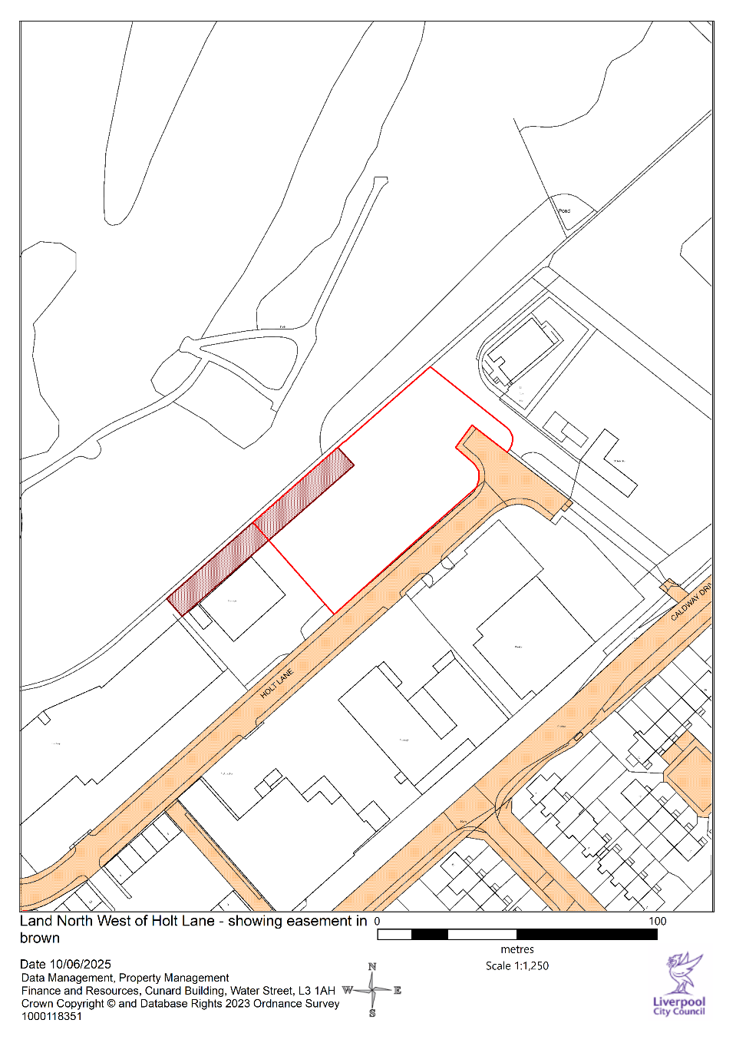

FURTHER INFORMATION AND VIEWINGS:

All enquiries for further information please contact:
Email address: Daniel.Murphy@liverpool.gov.uk
Liverpool City Council, Cunard Building, Water Street, Liverpool, L3 1AH
Consumer Protection from Unfair Trading Regulations 2008 and the Business Protection from Misleading Marketing Regulations 2008
The information provided in this brochure has been provided in good faith and is considered to be correct at the time of publication (Oct 2018)). Liverpool City Council (‘LCC’) has taken all reasonable precautions and has exercised all reasonable due diligence to ensure its accuracy. However, absolute accuracy cannot be guaranteed and must not be relied upon. All measurements, areas and boundaries are approximate and given for illustrative purposes only. Prospective purchasers must assure themselves, through their own investigations, that the information contained in these particulars is accurate and if there is any doubt to clarify it with LCC first. LCC, its agents and employees cannot be held responsible if the information in this brochure is subsequently relied upon by prospective purchasers who suffer loss as a result.

