 |  |  |  |  | 
 | FOR SALE |  |  |  | Residential Sale: 52 Council owned void properties requiring extensive refurbishment across Anfield, Edge Hill, Princes Park and Everton North wards.
Closing date:  August 2025  Residential  Opportunity |  |  |  | 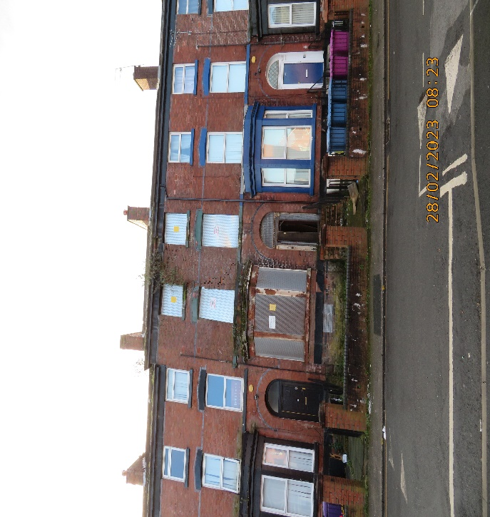
 |  |  |  | 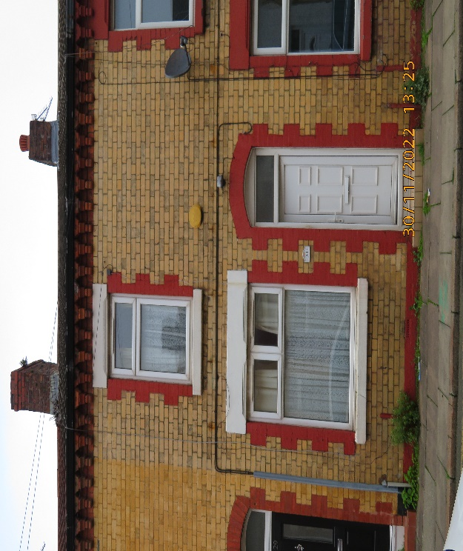

Description/Background:
Liverpool City Council (LCC) has identified 52 vacant residential units across the city, all of which are in a poor state of repair. The Council wishes to dispose of this package of units to a Registered Social Housing Provider or experienced developer to refurbish the properties.

One of the 4 key aims of the Housing Strategy is to improve homes and neighbourhoods, by bringing empty homes back into use. LCC is seeking to work with partners to deliver neighbourhood improvements, whilst meeting the immediate housing demand across the city. This vision aligns to the Liverpool Council Plan, which aims for residents live in safe, clean and welcoming neighbourhoods, and access affordable homes.

PROPERTY details & LOCATION:

- The City Council has recently completed a comprehensive review of 52 void houses across the city and wishes to market these properties which are in the Anfield, Everton North, Edge Hill and Princes Park wards. The 52 properties are all mid or end terraced houses and highlighted by ward in red on the attached site plans. A complete schedule of properties is included at Appendix A.
TENURE:
The City Council owns the freehold of all 52 properties and wishes to dispose of the portfolio on a long leasehold interest (250 years).

The Properties are to be used for residential use only. This strictly excludes the use of the Property for:
- Houses in Multiple Occupation
- Student accommodation
- Air bnb
The City Council will lease back 15 properties, identified in Appendix A, for the use of temporary and affordable housing accommodation. Any variation to the houses to be leased back by the City Council must be agreed between the parties prior to the long leasehold being entered. The successful bidder will be responsible for repairs and maintenance of all properties.
COUNCIL TAX:
On completion of the programme of works the properties will be subject to Council Tax. Please contact telephone no: 0800 0283686 or 0151 233 3008 for further information on council tax.

PLANNING:
The houses within the schedule are designated as primary residential in the Local Plan and the Council confirms that all properties should be refurbished and retained as housing stock for rent at market, affordable or social rent, or for owner occupiers.

The Planning Authority provide a pre-application service, details of which are via the attached link below. Any planning enquiries should be made through this process –
www.liverpool.gov.uk/business/planning-and-building-control/preparing-an-application/our-pre-application-service

ADDITIONAL COSTS:

All disposals are subject to payment of City Council Surveyor’s fees of 5% per property and Legal fees of 4%; this applies across the portfolio, or any variant grouping.

CONSIDERATIONS:
The Council is seeking submissions from interested parties, in particular the Council wishes to explore approaches from:
- Interested parties who have experience or can demonstrate they have the capacity/ability of managing properties.
- Interested parties who are looking to fully engage and work with the Council to improve the neighbourhood and housing offer across Anfield, Edge Hill and Princes ward, together with proposals as to how this can be achieved.
- Proposals for refurbishment that deliver high quality affordable housing that successfully integrates with the existing housing and area.
- Proposals that include rental modelling at market, affordable and/or social rent.
- Proposals that maintain or increase individual bed size and satisfy Planning use Type C3 (a).
- The Council will consider offers for suitable smaller groupings of the housing within the Property Portfolio. Any variant offers will only be considered were the disposal of properties in a smaller group does not undermine the viability and sale of the total 52 units included in the sale.
- The Council’s preference is to dispose of all 52 properties to one suitable bidder who meets the criteria set out in this document.
The three groups of properties are identified in Appendix A and:
Variant bids will only be considered for the following property groupings:
- Anfield A (14 properties including a minimum of 7 for LCC Leaseback at market rent or lower).
- Anfield B (9 properties at Oakfield Rd).
- Picton and Granby (29 properties including a minimum of 8 for LCC Leaseback at market rent or lower).
Houses to be let-back to the City Council
- Proposals to include details of your management arrangements for the houses, including your lettings policies. Your response should include evidence of managing properties and a five-year rental model for lease-back.
FORMAL OFFERS & SUBMISSION PROCESS:
Liverpool City Council will consider all formal written offers made by the closing date detailed below. In compliance with s123 of the Local Government Act 1972 the Council must achieve best consideration for all disposals. The Council is not bound to accept the highest or any offer made.
Interested parties are required to provide the following information:
General
- Completed Due Diligence form attached to this document (see appendix B).
- Full details of the individual / company.
- An organogram of your management team and proposed project team for delivering the refurbishment programme, including CV’s.
- Written details of your proposal for the properties, including plans for refurbishment.
- A financial offer for the properties.
- A programme for delivery of the refurbishment programme including a projected tenancy date.
- Proposed community consultation arrangements regarding your proposals for the house refurbishments.
- Any other information relevant to your bid.

We also require specific responses to the following five questions:
Q1 | Cost and Value Engineering  • Please provide a detailed cost breakdown for the project?  • How do you ensure cost control during the project?  • What value engineering suggestions can you offer to enhance efficiency or reduce costs? | 10%
Q2 | Approach to Project Delivery  • What is your proposed project timeline, including key milestones?  • How do you plan to manage potential delays and risks?  • What is your approach to quality assurance and control during construction? | 10%
Q3 | Risk Management  • What are the three top risks to programme delivery and how will you mitigate them? | 10%
Q4 | Development and Construction Experience  Please provide an overview of your company and its development history in Liverpool and the North West?  • What similar projects have you successfully completed in the past five years?  • Can you provide client references for similar projects?  • How do you ensure quality and consistency across your projects? | 10%
Q5 | Financial Modelling  • Please provide details of proposed tenure type across the portfolio of housing. | 10%
Total |  | 50%

Please format your submission in 11pt Calibri (Body) font and provide it formatted as A4 in Microsoft Word or an equivalent word processing format.
Submissions must not be in a PDF format. Your submission must not exceed the number of pages indicated (one page comprises one side of A4) for each question, and any part of the submission exceeding the page limit shall be disregarded. The page limits include all text, tables, images, and diagrams. Each criterion is of equal importance and will be worth 10% of the overall total.
Evaluation Process
We will evaluate offers on a 50:50 split - Offer:Quality (Questions 1-5 above)
1) The Council is not bound to accept the highest or any offer made.
2) The Council reserves the right to shortlist submitted offers pending future negotiation.
3) Submissions should be made by email ONLY to the email address below.

Submission and Evaluation Timeline

Submission of offer Due Date: to be received via email to voidhousingprogramme@liverpool.gov.uk by: Monday 25th August 2025, by 9 a.m.
• Review and Selection Period: September 2025
• Notification of winning submission: October 2025
• Property handover: October/November 2025
FURTHER INFORMATION AND VIEWINGS:
The Council will arrange for a sample number of houses to be external viewed on the following dates and times. Due to the poor condition of the houses, internal viewings are prohibited due to health and safety concerns.
Viewing arrangements (internal and external):
9.30am, Monday 7th July 2025 (Picton)
9.30am, Tuesday 8th July 2025 (Anfield/Everton North)
If you wish to attend either or both viewings, please confirm your attendance to the email address below by Friday 27th June 2025.

All submission enquiries and for any further clarification please contact:
Email address: voidhousingprogramme@liverpool.gov.uk
Liverpool City Council, Cunard Building, Water Street, Liverpool, L3 1AH
APPENDICES
Appendix A: Schedule of properties
Appendix B: Due Diligence information form
Appendix C-G: Properties by ward site plans
Appendix H: Heads of Terms

