|  |  |  |  |  |
| --- | --- | --- | --- | --- |
|  |  |  |  |  |
|  |  |  |  |  |
| TIO | **To Let Lease** |  | **Commercial and Industrial Letting Opportunity – Units Tetlow Way, Langham Street Liverpool L4 4DA** |  |
|  |  |  |  |  |
| ==` | **Commercial and Industrial Letting Opportunity** |  | PHOTO |  |
|  | LOCTION PLAN |
|  |





Unit A2

Tetlow Way

Unit A9

Tetlow Way

Unit B1

Tetlow Way

Unit B3

Tetlow Way

Unit B5

Tetlow Way

**Description/Background:**

Liverpool City Council is offering the opportunity to lease commercial/ Industrial units, individually or as multiple units. The council is asking for expressions of interest from either individuals or businesses within the city in acquiring a new lease for the properties mentioned.

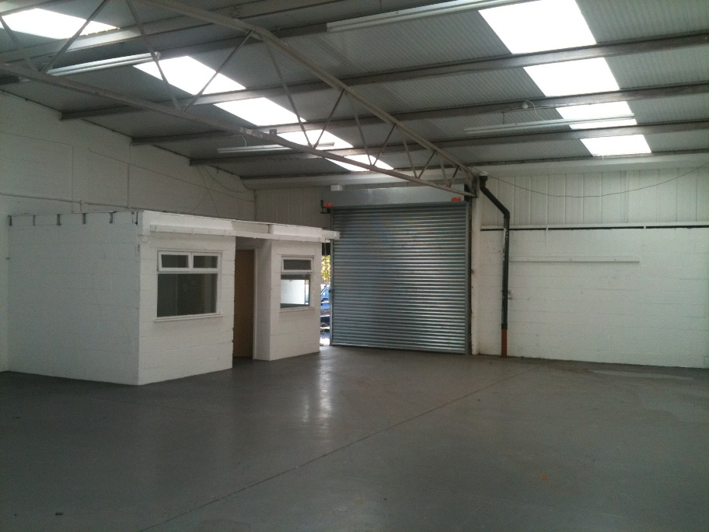

The subject properties are purpose built 1970’s single storey units, having block and brick built walls with pitched profile metal roofs with interspaced roof lights. Internally they offer an open storage/production area and single WC. The units provide a single-phase electricity supply. A gas supply exists at some of the units. Externally each unit benefits from the use of a forecourt area to the front of the property.

The properties are in tenantable condition but may require some small refurbishments. Floor plans undertaken by the Council are available on request. Further surveys by interested parties is recommended.

**Site details & LOCATION:**

The development is located approximately two miles north of Liverpool City Centre on the Tetlow Way/ Langham Street Industrial Estate in the Walton area of Liverpool. Everton FC Goodison and Stanley Park are nearby. Langham Street is located off A59 Walton Road which provides good links to the Mersey Tunnels, City Centre as well as the outer suburbs of Liverpool.

There are five units available on the development, the measurements for each unit varying between approximately 117 m2 (1,237 ft2) and 172 m2 (1,850 ft2). Prospective purchasers should seek specialist advice regarding surveys and valuation.



**FINANCIAL OFFER:** Liverpool City Council would consider all offers based on reasonable market rent. In compliance with s123 of the Local Government Act 1972 the Council must achieve best value/consideration for all disposals.

**TENURE:** The City Council owns the freehold to the properties which are ready to be let at market value, some being vacant and others due to be handed back shortly. Tenants will be offered a 5 year lease with options of 10 and 15 available.

**RATES:**

Please contact 0151 233 3000 for further information on business rates or visit <https://liverpool.gov.uk/business/business-rates/>.

**PLANNING:**

Interested parties should also make themselves aware of relevant planning policy relating to mixed-use development in this location, including the Liverpool Unitary Development Plan, Anfield – Spatial Regeneration Framework and advice at the following link:-

[www.liverpool.gov.uk/planning-and-building-control/guidance-and-policies/advice-notes/](http://www.liverpool.gov.uk/planning-and-building-control/guidance-and-policies/advice-notes/)

The Planning Authority provide a pre-application service, details of which are on the attached link below. Any planning enquiries should be made through this process –

[www.liverpool.gov.uk/business/planning-and-building-control/preparing-an-application/our-pre-application-service](http://www.liverpool.gov.uk/business/planning-and-building-control/preparing-an-application/our-pre-application-service)

**ADDITIONAL COSTS:**

All new lettings are subject to the payment of the City Councils surveyor’s fees £3,000 and legal fees £1,000.

**CONSIDERATIONS:**

The Council is seeking submissions from interested parties of various Industrial, commercial, office use.

**FORMAL OFFERS & SUBMISSION PROCESS:**

1) The Council is not bound to accept the highest or any offer made;

2) The Council reserves the right to shortlist the submitted offers pending future negotiation;

3) The Council reserves the right to end the tender process at any time.

4) Interested parties will be expected to complete and pass the Councils Due Diligence process;

Plan:



**FURTHER INFORMATION AND VIEWINGS:**

Viewings of the properties are available.

All enquiries and for further information please contact:

Email address: [Ian.Hodgson@liverpool.gov.uk](mailto:Ian.Hodgson@liverpool.gov.uk) This email address is for enquiries only.

Liverpool City Council, Cunard Building, Water Street, Liverpool, L3 1A





Consumer Protection from Unfair Trading Regulations 2008 and the Business Protection from Misleading Marketing Regulations 2008

*The information provided in this brochure has been provided in good faith and is considered to be correct at the time of publication (Oct 2018)). Liverpool City Council (‘LCC’) has taken all reasonable precautions and has exercised all reasonable due diligence to ensure its accuracy. However, absolute accuracy cannot be guaranteed and must not be relied upon. All measurements, areas and boundaries are approximate and given for illustrative purposes only. Prospective purchasers must assure themselves, through their own investigations, that the information contained in these particulars is accurate and if there is any doubt to clarify it with LCC first. LCC, its agents and employees cannot be held responsible if the information in this brochure is subsequently relied upon by prospective purchasers who suffer loss as a result.*