TIO | To Let Lease |  | Commercial and Industrial Letting Opportunity – Blackstock Street Vauxhall
==` | Commercial and Industrial Letting Opportunity |  | 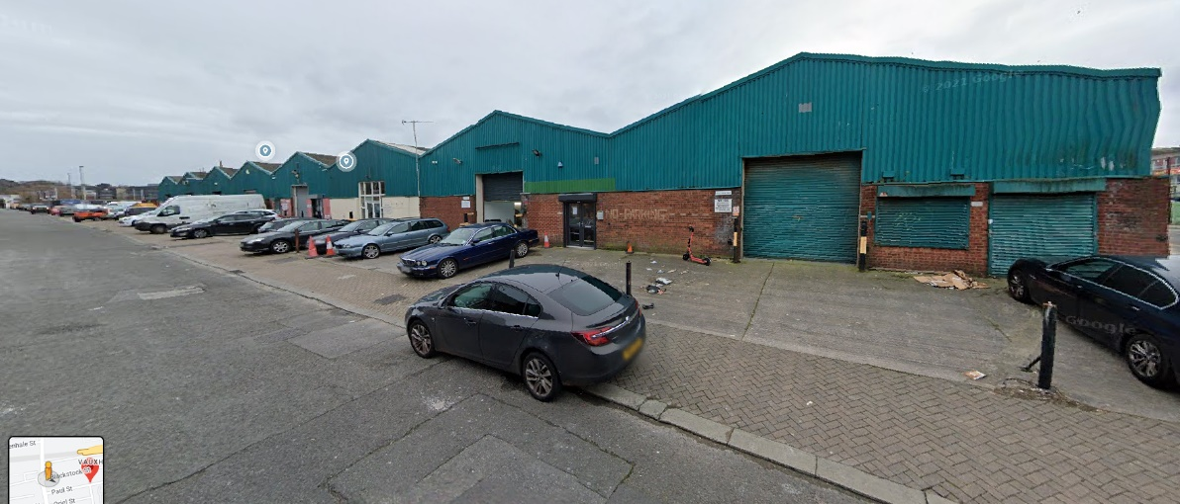  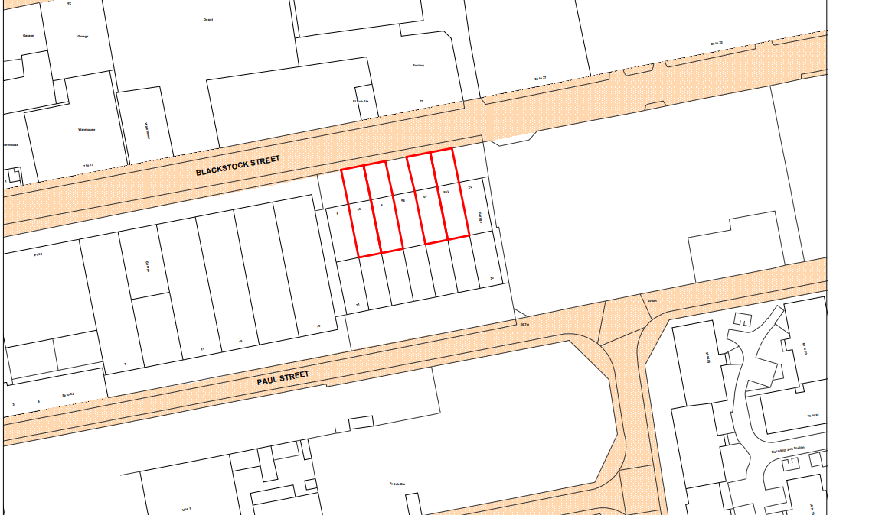

Unit 2, 6A Blackstock street

Unit 1, 6 Blackstock street

Unit 5, 10 Blackstock street

Unit 7, 12 Blackstock street

Description/Background:

Liverpool City Council is offering the opportunity to lease a number of commercial/ Industrial units, individually or as multiple units. The council is asking for expressions of interest from either individuals or businesses within the city in regards to acquiring a new lease for the properties mentioned.

The subject properties are purpose built single storey advanced factory units which forms part of a block of seven identical units. The property is block and brick built and the roof is pitched profile metal with interspaced roof lights. Internally the property offers an open storage/production area and single WC. The unit provides a water and single phase electricity supply. A gas supply does not exist. Externally the property benefits from the use of a forecourt area to the front of the property.
The properties are in tenantable condition but may require some small refurbishments. Floor plans undertaken by the Council are available on request. Further surveys by interested parties is recommended.
Site details & LOCATION:
The property is located approximately half a mile north of Liverpool City Centre on the Paul Street/Blackstock Street Industrial Estate in the Vauxhall area of Liverpool. Paul Street is located off Vauxhall Road which can be accessed via Leeds Street and provides good links to the Mersey Tunnels, City Centre as well as the outer suburbs of Liverpool.
There are four properties on Blackstock Street the measurements for each unit vary between approximately range from 95.5m² to 97.5m². Prospective purchasers should seek specialist advice regarding surveys and valuation.
FINANCIAL OFFER: Liverpool City Council would consider all offers based on reasonable market rent. In compliance with s123 of the Local Government Act 1972 the Council must achieve best value/consideration for all disposals.
TENURE:
The City Council owns the freehold to the properties, all of which are currently vacant and ready to be let at market value. Tenants will be offered a 5 year lease contracted out of the 1954 Landlord and Tenant Act

RATES:
Please contact 0151 233 3000 for further information on business rates or visit https://liverpool.gov.uk/business/business-rates/.

PLANNING:
Interested parties should also make themselves aware of relevant planning policy relating to mixed-use development in this location, including the Liverpool Unitary Development Plan, Anfield – Spatial Regeneration Framework and advice at the following link:-

www.liverpool.gov.uk/planning-and-building-control/guidance-and-policies/advice-notes/

The Planning Authority provide a pre-application service, details of which are on the attached link below. Any planning enquiries should be made through this process –

www.liverpool.gov.uk/business/planning-and-building-control/preparing-an-application/our-pre-application-service

ADDITIONAL COSTS:

All new lettings are subject to the payment of the City Councils surveyor’s fees £3000 and legal fees £1000.

CONSIDERATIONS:
The Council is seeking submissions from interested parties of various Industrial, commercial, office use.

FORMAL OFFERS & SUBMISSION PROCESS:
1) The Council is not bound to accept the highest or any offer made;
2) The Council reserves the right to shortlist the submitted offers pending future negotiation;
3) The Council reserves the right to end the tender process at any time.
4) Interested parties will be expected to complete and pass the Councils Due Diligence process;

FURTHER INFORMATION AND VIEWINGS:
Viewings of the properties are available.
All enquiries and for further information please contact:
Email address: Jamie.McManus@liverpool.gov.uk
This email address is for enquiries only.
Liverpool City Council, Cunard Building, Water Street, Liverpool, L3 1AH

PLAN.
Consumer Protection from Unfair Trading Regulations 2008 and the Business Protection from Misleading Marketing Regulations 2008
The information provided in this brochure has been provided in good faith and is considered to be correct at the time of publication (Oct 2018)). Liverpool City Council (‘LCC’) has taken all reasonable precautions and has exercised all reasonable due diligence to ensure its accuracy. However, absolute accuracy cannot be guaranteed and must not be relied upon. All measurements, areas and boundaries are approximate and given for illustrative purposes only. Prospective purchasers must assure themselves, through their own investigations, that the information contained in these particulars is accurate and if there is any doubt to clarify it with LCC first. LCC, its agents and employees cannot be held responsible if the information in this brochure is subsequently relied upon by prospective purchasers who suffer loss as a result.

