|  |  |  |  |  |
| --- | --- | --- | --- | --- |
|  |  |  |  |  |
|  |  |  |  |  |
| TIO | **To Let** |  | **EXPRESSIONS OF INTEREST SOUGHT FOR:  512 Mather Avenue Liverpool, L19 4UF – Suitable for various retail uses.** |  |
|  |  |  |  |  |
| ==` | 512 Mather Avenue Liverpool, L19 4UG.  Seeking various retail uses.  Approximate site area: 106.7m2  6 November 2023  **RETAIL OPPORTUNITY** |  |  |  |
|  |  |
|  |





**Description/Background:**

Liverpool City Council is asking for Expressions of Interests from individuals, existing businesses, new businesses and other organisations interested in taking a lease of the retail units for commercial use in Liverpool. In particular, it wishes to encourage local residents and businesses to the area to create a new retail offer within the Mather Avenue shopping parade for the South of Liverpool.

The property comprises of a two story retail unit located within a shopping parade containing a total of nine retails units. The premises is constructed of brick under a pitched concrete tile roof. It benefits from first floor space which will be restricted to business use only. It also has the benefit of parking bays which are situated at the front of the parade. The premises to let has the added benefit of a steel roller to the shop front and a small rear yard which provides access to a service road/alleyway.

**Site details & LOCATION:**

The retail unit is situated on Mather Avenue shopping parade, approximately five miles from the city centre. This site is situated in a residential area providing footfall for the existing shops.

The unit has approximately 106.7m2 of retail space. Measurements and areas stated above may be approximate and purchasers should make their own accurate measurements. Prospective tenants should seek specialist advice regarding surveys and valuation.

**GUIDE RENT:** £14,000 per annum

**SERVICE CHARGE:** There is a service charge which is applicable to the whole site, the current service charge for the subject property is £1052.98 per annum, which is payable annually in advance and is subject to annual review.

**TENURE:**

The City Council owns the freehold to the shopping parade and proposes a ten year Internal Repairing Insuring lease. Subject to contract and City Council approval. (Details to be agreed with the Council)

**RATES:**

Please contact 0151 233 3008 for further information on business rates.





**PLANNING:**

Interested parties should also make themselves aware of relevant planning policy relating to changes of use for commercial property, including advice on the following link:-

www.liverpool.gov.uk/planning-and-building-control/guidance-and-policies/advice-notes/

The Planning Authority provide a pre-application service, details of which are on the attached link below. Any planning enquiries should be made through this process - www.liverpool.gov.uk/business/planning-and-building-control/preparing-an-application/our-pre-application-service

**ADDITIONAL COSTS:**

All lettings are subject to the payment of the City Councils surveyor’s fees £2,000 and legal fees £1,000.

**CONSIDERATIONS:**

The Council is seeking submissions from both individuals and businesses interested in various retail uses for this site. In particular it wished to explore approaches from:

* Individuals/Communities/Businesses interested in a variety of retail uses such as off licence, newsagents, grocers, bakery, butchers, beauty salon and any other type of business which compliments the existing businesses on the parade.
* Submissions that provide new retail uses to the parade.
* Proposals from small businesses wishing to expand their business operations.

**FORMAL OFFERS & SUBMISSION PROCESS:**

Formal written offers are sought from interested parties who are required to provide the following information;

* Full details of the individual/company
* Written details of your proposed use for the property
* A rental offer for the property
* Evidence of any previous business experience
* Your business plan for the next five years.
* Any other relevant information.

1) The Council is not bound to accept the lowest or any offer made;

2) The Council reserves the right to shortlist the submitted offers pending future negotiation;



3) Submissions should be made by email **ONLY** to the email address below;

**Christine.owen@liverpool.gov.uk**

Submissions should be made by **Monday 4 December 2023.**

**FURTHER INFORMATION AND VIEWINGS:**

All enquiries and for further information please contact:

Email address: [christine.owen@liverpool.gov.uk](mailto:robyn.challinor@liverpool.gov.uk)

Telephone: 07305 271425

Liverpool City Council, Property and Asset Management Services, Cunard Building, Water Street, Liverpool, L3 1AH

**PLAN**

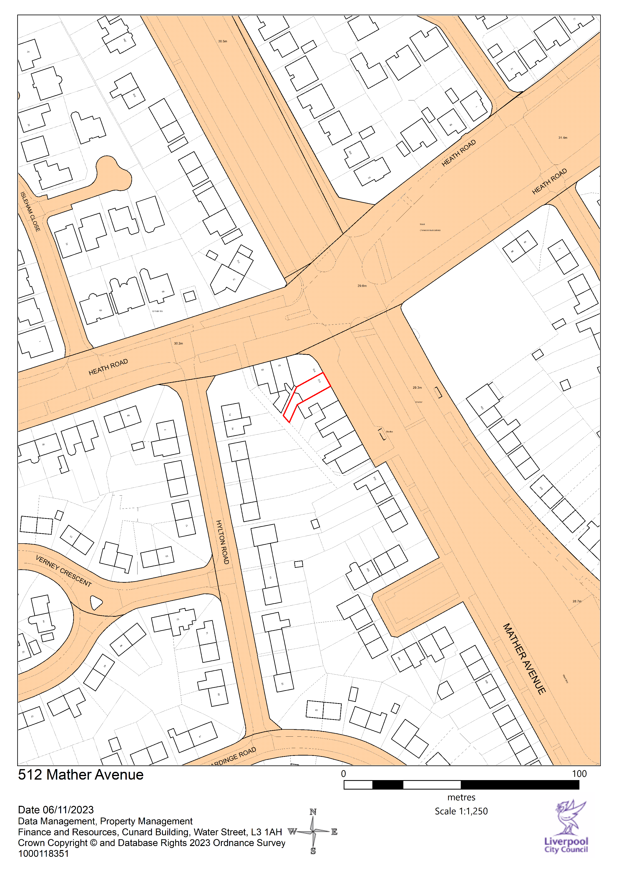





Consumer Protection from Unfair Trading Regulations 2008 and the Business Protection from Misleading Marketing Regulations 2008

*The information provided in this brochure has been provided in good faith and is considered to be correct at the time of publication (Oct 2018)). Liverpool City Council (‘LCC’) has taken all reasonable precautions and has exercised all reasonable due diligence to ensure its accuracy. However, absolute accuracy cannot be guaranteed and must not be relied upon. All measurements, areas and boundaries are approximate and given for illustrative purposes only. Prospective purchasers must assure themselves, through their own investigations, that the information contained in these particulars is accurate and if there is any doubt to clarify it with LCC first. LCC, its agents and employees cannot be held responsible if the information in this brochure is subsequently relied upon by prospective purchasers who suffer loss as a result.*