TIO | FOR SALE  BY WAY OF AN INFORMAL TENDER |  | Industrial/Residential Opportunity, 1 Carruthers Street, Liverpool, L3 6BY
Industrial & Residential Opportunity Subject to Planning Consent

Detached Industrial Warehouse

Pumpfields Area

Highly Desirable Location

==` |  |  | 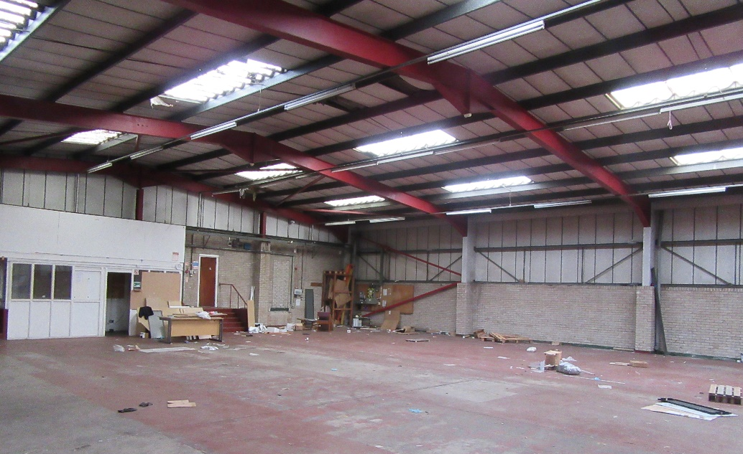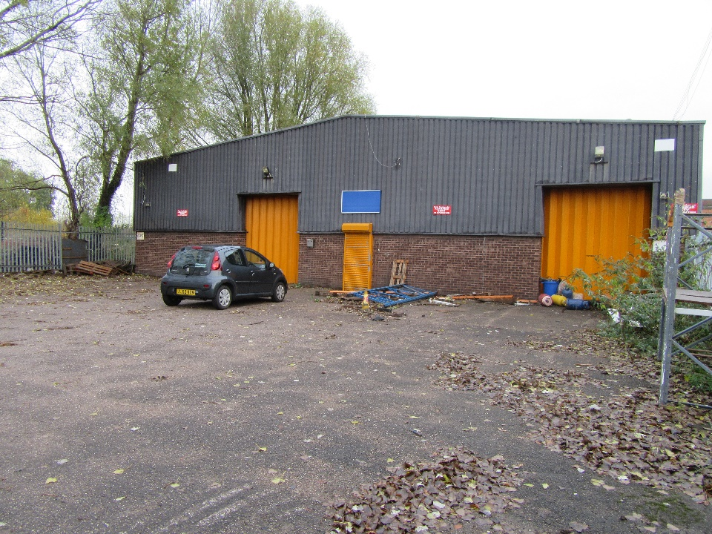
 |  |  | 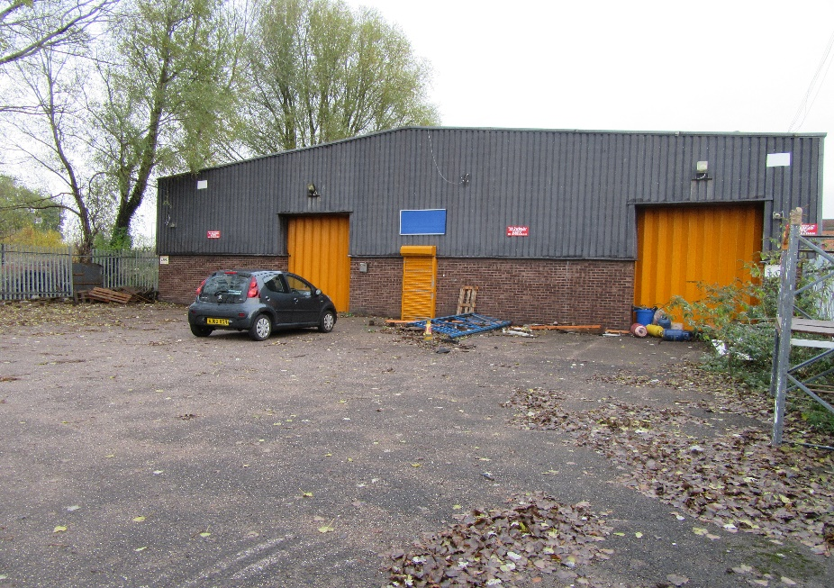

Description/Background:
The property was historically and most recently utilised as an industrial unit comprising of a large workshop/storage area with six offices and amenity/welfare facilities at the rear of the site. The yard at the rear of the industrial unit can be accessed via Carruthers Street.
The property will be disposed of by way of an informal tender, the interested parties should put forward their expression of interest based on a reasonable market value offer. Their expression of interest should include the following:
- Financial Offer (How much the interested party are prepared to bid for the property).
- Proposed Scheme details/plans.
- Timescale for completion.
- Whether contact with the local planning department has been made.

It should be noted that there will be strict deadlines in place to make sure any proposed scheme that is granted is adhered to and work is commenced in a timely fashion.

Site details & LOCATION:

The property is located between Carruthers Street and Vauxhall Road and is approximately 0.5km north of the City Centre. The site is located within a predominately mixed-use area with residential, commercial and industrial sites in close proximity. The site has immediate access to the Kingsway Tunnel, A59 and A5053 and provides excellent accessibility to the site. The property comprises of a single storey detached industrial warehouse building of steel portal framed construction. The property benefits from an enclosed hardstanding yard area with fencing around the perimeter.
ACCOMMODATION:
Main Workshop/Storage Area 543 sq.m
Industrial Unit GIA 721 sq.m
Total Site Area 1699 sq.m
FINANCIAL OFFER:
Liverpool City Council would consider all offers based on best consideration and above. In compliance with s123 of the Local Government Act 1972 the Council must achieve best consideration for all disposals.
TENURE:
The City Council owns the freehold of 1 Carruthers Street, however, are disposing of the site by way of a long leasehold interest of 125-years.
RATES:
Please contact the below website for further information on business rates - https://liverpool.gov.uk/business/business-rates/.
PLANNING:

Interested parties should also make themselves aware of relevant planning policy relating to the Pumpfields area. The area provides a wide range of mixed-use developments including residential, industrial and commercial. The Liverpool Local Plan 2013–2033 - Liverpool City Council/
The Planning Authority provide a pre-application service, details of which are on the attached link below. Any planning enquiries should be made through this process -
www.liverpool.gov.uk/business/planning-and-building-control/preparing-an-application/our-pre-application-service

ADDITIONAL COSTS:

All disposals are subject to the payment of the City Councils Surveyors’ fees at 5% and Legal fees at 4%.

CONSIDERATIONS:
The Council is seeking expressions of interest from interested parties on the property at 1 Carruthers Street.
- 125-year lease to be granted.
- Full Repairing and Insuring (FRI) lease.
- To be used for either industrial use or redeveloped into residential use subject to planning permission. It is to be noted that planning consent has not been applied for and it will be down to the lessee to gain consent.

The following uses will not be permitted:
- Betting Office.
- Taxi Office.
- Private Members’ Cinema Club.
- Sex Establishment.
- For the operation and use of space invaders or similar video games.
- Amusement Arcade.
- Radio communication masts/aerials.
- Tobacco shop.
- Planning permission to be applied for within 6 months of the lease commencement date.
- Works to be completed within 24 months of planning approval.
- And all the other standard lease terms.

FORMAL OFFERS & SUBMISSION PROCESS:
Formal written offers are sought from interested parties who are required to provide the following information.
- Full details of the individual/company.
- A financial offer for the property.
- Details of planned use for the property.
- Liverpool City Council would consider all offers based on best consideration and above. In compliance with s123 of the Local Government Act 1972 the Council must achieve best consideration for all disposals.
- The Council is not bound to accept the highest or any offer made. (The Council has a duty to achieve best consideration taking into consideration the scheme and what benefits the public. However, no offer less than best consideration will be considered).
- The Council reserves the right to shortlist the submitted offers pending future negotiation.
- The Council reserves the right to end the tender process at any time.
- Interested parties are expected to complete and pass the Councils Due Diligence process.
- Submissions should be made by email ONLY to the email address below.
- Submissions should be made by 12pm Monday 14th August 2023. Any proposals submitted after 12pm Monday 14th August 2023 will not be considered.

FURTHER INFORMATION AND VIEWINGS:

All enquiries for viewing dates and for further information please contact:
Email address: Daniel.Murphy@liverpool.gov.uk
Liverpool City Council, Cunard Building, Water Street, Liverpool, L3 1A

Consumer Protection from Unfair Trading Regulations 2008 and the Business Protection from Misleading Marketing Regulations 2008
The information provided in this brochure has been provided in good faith and is considered to be correct at the time of publication (Oct 2018)). Liverpool City Council (‘LCC’) has taken all reasonable precautions and has exercised all reasonable due diligence to ensure its accuracy. However, absolute accuracy cannot be guaranteed and must not be relied upon. All measurements, areas and boundaries are approximate and given for illustrative purposes only. Prospective purchasers must assure themselves, through their own investigations, that the information contained in these particulars is accurate and if there is any doubt to clarify it with LCC first. LCC, its agents and employees cannot be held responsible if the information in this brochure is subsequently relied upon by prospective purchasers who suffer loss as a result.

